Creamy Garlic Mushrooms and Bacon
Prep Time 10 mins Cook Time 30 mins
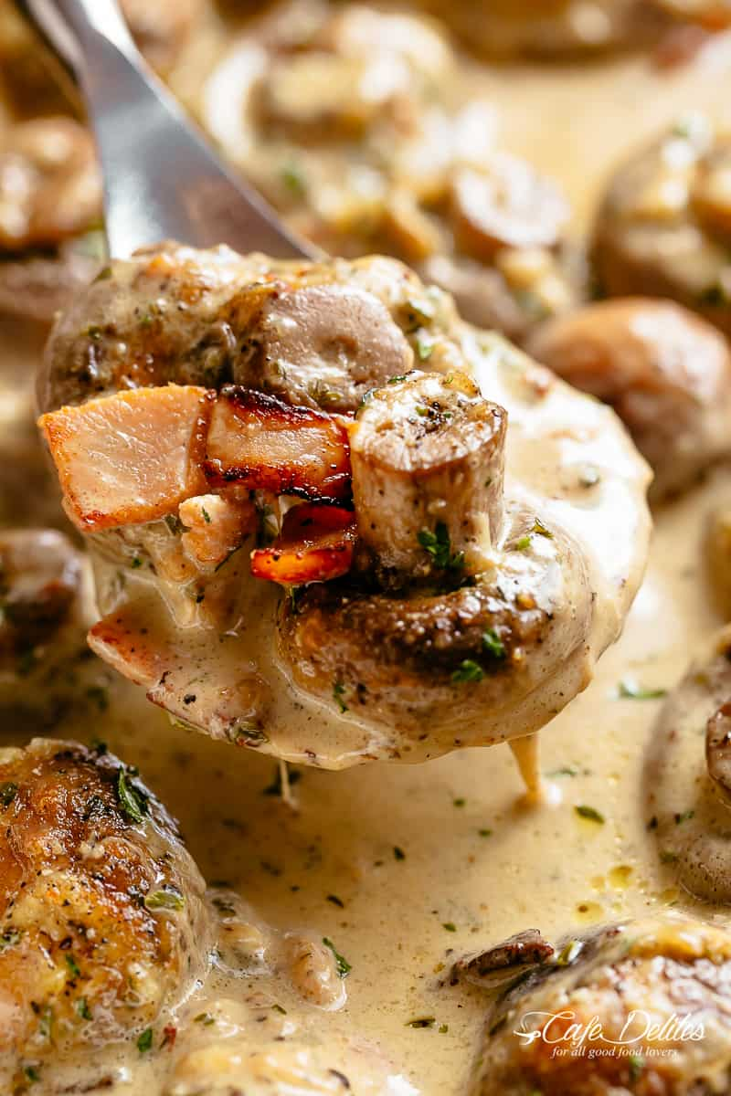
8 Servings
Ingredients
8 ounces bacon, cut into strips
2 Tbsp butter
26 oz brown mushrooms
1 tbs olive oil
¼ cup dry white wine (or chicken broth/stock)
6 cloves garlic finely chopped
1½ cups heavy cream
1 tsp fresh chopped thyme
½ cup fresh shredded or grated mozzarella
¼ cup fresh shredded or grated parmesan cheese
Directions
- Fry the bacon in a large oven-safe skillet over medium heat until crispy. Remove the bacon and set onto a paper towel lined plate to soak up some of the oil. Set aside.
- In the same pan, melt the butter. Add the mushrooms, drizzle with oil and mix through, scraping up any browned bits from the bottom of the pan. Fry for 2-3 minutes to lightly brown mushrooms and release their juices.
- Pour in the wine (or broth) and let reduce for 2 minutes, while occasionally stirring.
- Add in the garlic and stir it through for a minute, until fragrant. Pour in the cream and herbs. Reduce heat down to low. Gently simmer until tender (about 4-5 minutes) and sauce is slightly thickened.
- Add the bacon back in and give everything a good mix to combine all of the flavors together. Top the mushrooms with the mozzarella and parmesan cheese.
- Broil until cheese is melted and bubbly and mushrooms are done to your liking (about 3-5 minutes).

